**8 IN 1 ROBOT**

A robot is a machine designed to execute one or more tasks automatically with speed and precision. There are as many different types of robots as there are tasks for them to perform. Combining 8 robots in 1 can make our robot multipurpose and more interesting. It is an Arduino based robot working with different sensors for different tasks to perform.

**PCB LAYOUT:**

**Front Layout:**

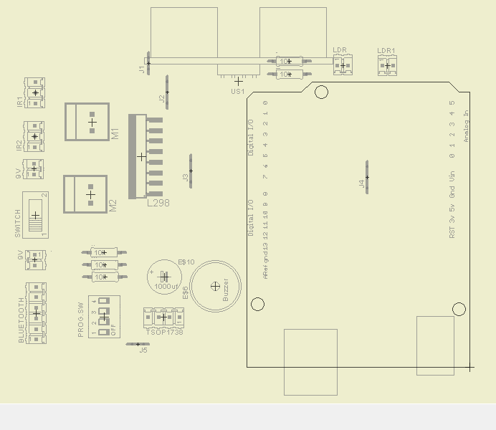

**Back Layout:**

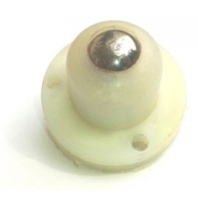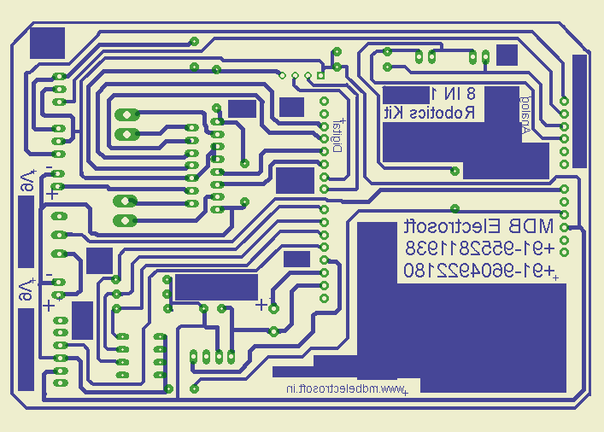

Components used:

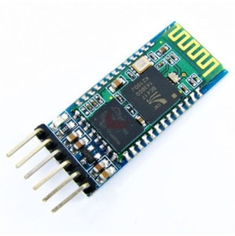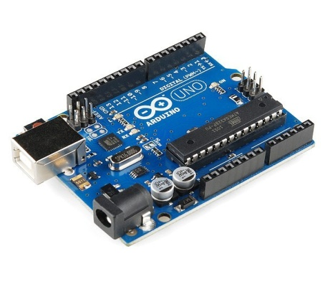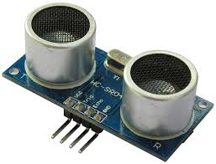

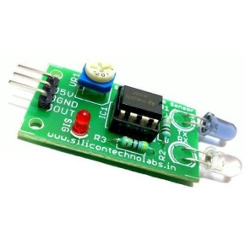

Ultrasonic Sensor Bluetooth Module IR Module

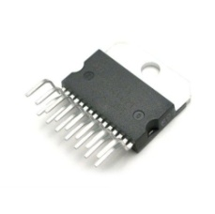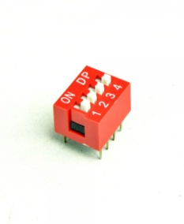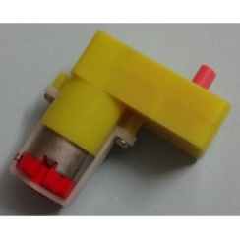 Arduino

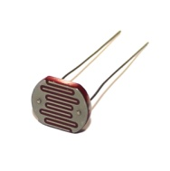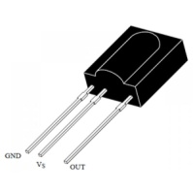

TSOP LDR Single Shaft Bo Motor Motor Driver L298 4 Way DIP Switch

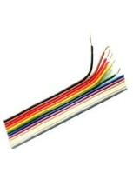

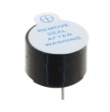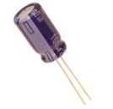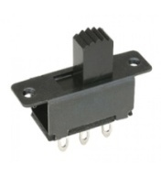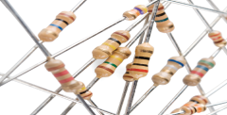

Resistors(47K & 10K) Sliding Switch Buzzer Capacitor Ribbon Wires

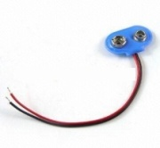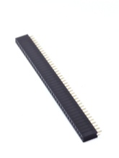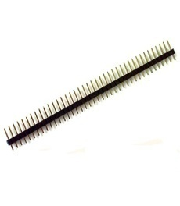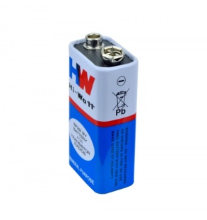

9V Battery Snapper Female Bus Strip Male Bus Strip Castor Wheel

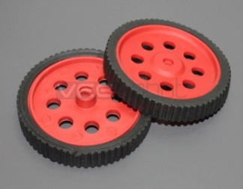 Wheels Robot Chasis

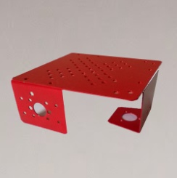

1. Remote Control Robot :

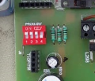This is this Arduino and Bluetooth based robot. In this we need to keep the switches position as shown. This robot is controlled by connecting our mobile with the Bluetooth module on robot. There are many apps available, but we will be using Arduino RC here. Connect the module on robot and control it by controlling different button on screen of mobile as shown in video.

1. Gesture Control Robot:

This is again the Arduino and Bluetooth based robot. Switches position, App and connectivity process are again the same. In this you have to go with the vehicle mode in the app. So enjoy this Gesture Control Robot by keeping your mobile at different position.

1. Voice Control Robot:

This is also the Arduino and Bluetooth based Robot. Switches position are same. App that needs to be used for this is Arduino Voice Control. Connect the mobile with the module and control your robot with different letters (here predefined in code). Refer video.

1. 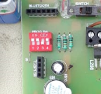IR Remote Control Robot:

In this robot, a TV Remote is utilized for the controlling purpose. All you need to do is just observe the codes that are generated by the different buttons of remote. For this you can refer code of IRrecvDemo in Arduino. Use that codes and control the robot.

1. Obstacle Avoider:

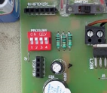In this robot, we will be using Ultrasonic sensor to avoid the obstacle. Switches position will be different for this (refer image). Ultrasonic sensor is a device which can measure the distance. So any particular distance can be used as a reference and thus robot can be controlled to avoid any obstacle. Here we are using only one ultrasonic sensor which will be placed at the front side of the robot to avoid any obstacle in front of the robot. Using 3 ultrasonic sensors, we can make this robot more accurate that will avoid the obstacles to its all front, left and right sides.

1. Wall follower:

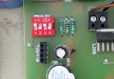This is a robot which will follow the wall if placed closed to it. Here also we are using 1 sensor due to which our robot will follow the wall from only its one side. And if used 3 sensors, then a robot can be made which will follow any wall. Working principle is also the same here as we are using ultrasonic sensor. Code and switches positions for this robot are different than the obstacle avoider.

1. Light Chaser:

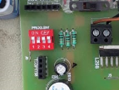This robot detects the light and chases it. In this we are using 2 LDR to sense the light. Whenever the light falls on the LDR, the robot will turns its direction towards the light and follows it smoothly. Refer image for the switches position.

1. Line Follower Robot:

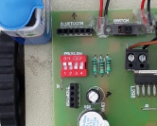This is an interesting robot that follows the line. We are using 2 IR Modules for this. IR Module is a device having IR LED and Photodiode on it. Light has a tendency to get reflected from light color (White) and get absorbed by dark color (Black). So this concept is used to make line follower robot in which IR LED emits the light and Photodiode detects it if reflected. Whenever the light IR light falls on the black color, it will get absorbed and the robot will change its direction by small angle. Thus robot will be able to follow the whole track made by dark color (black). Keep the switches position as shown in image.